**SQL Problem Statements**

1. Create two tables given in image (Save create query)
2. Get Employee Detail having Max Salary
3. Get Employee Detail having Min Salary
4. Get Employee Detail having Last Name Starting with “R”
5. Get Employee Detail with columns

* EmpID
* FullName
* ManagerName
* Total Salary
* Project

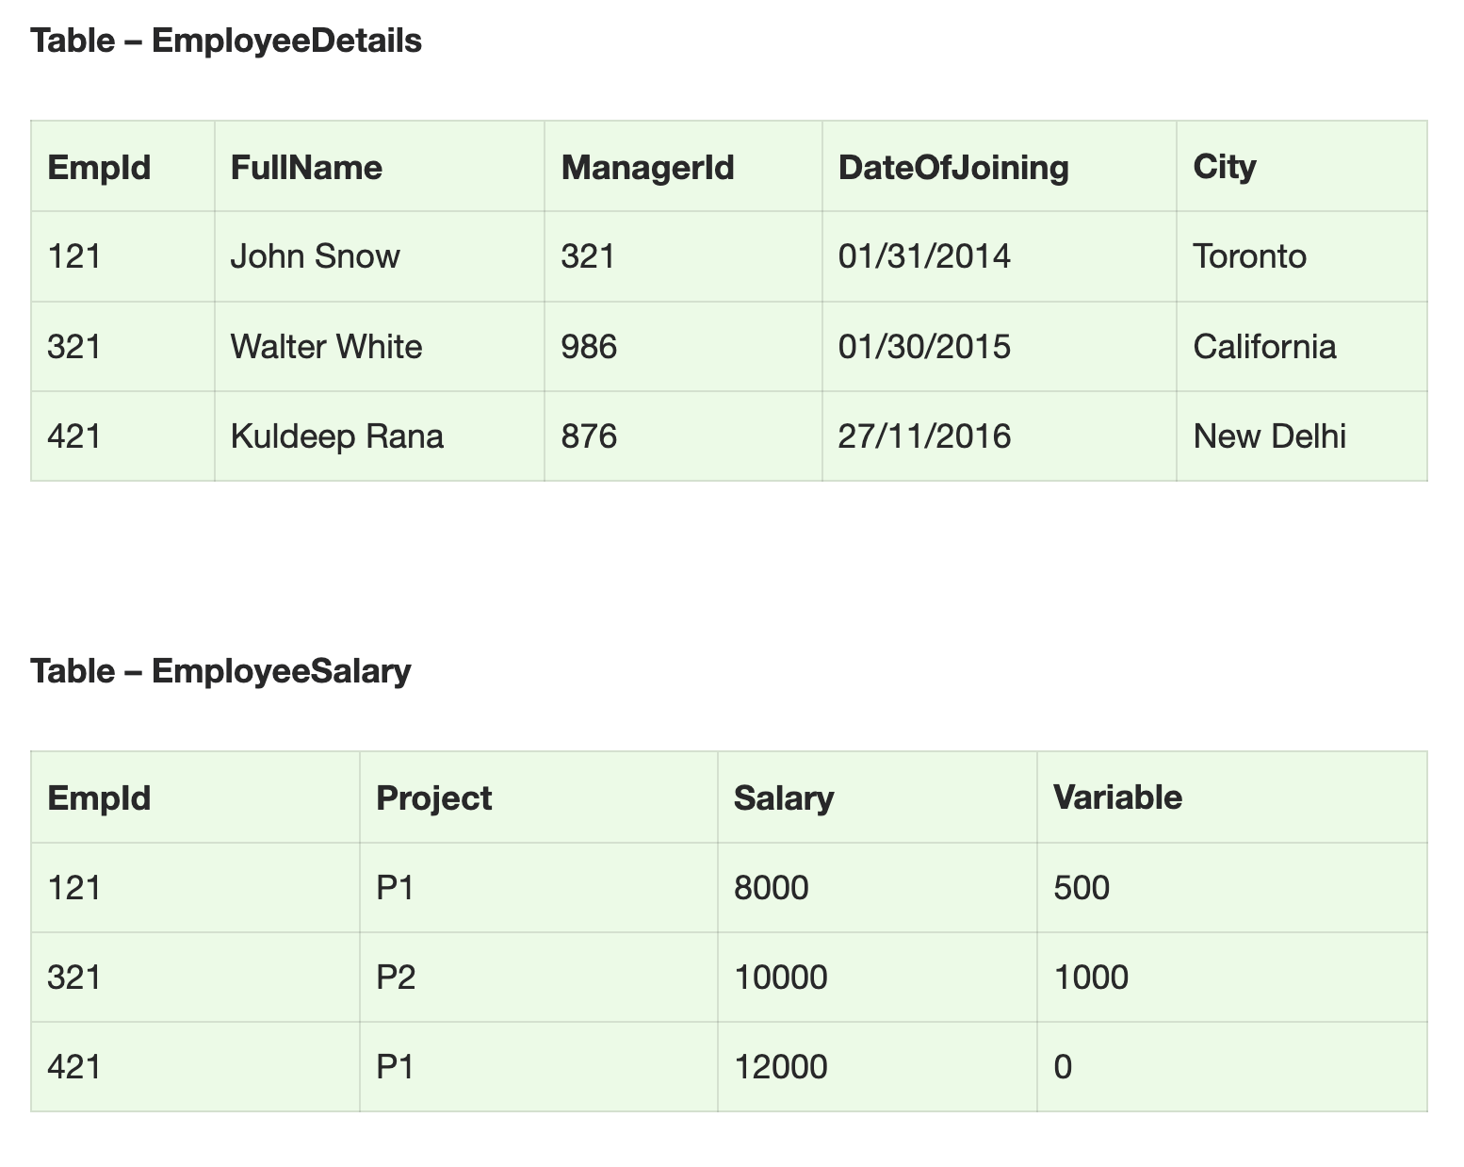

**Solution**

1.Create two tables given in image (Save create query)

**Script**

**Table 1**

CREATE TABLE EmployeeDetails

(

EmpId int,

FullName nvarchar (255),

ManagerId int,

DateOfJoining nvarchar (255),

city nvarchar(200)

)

SELECT * FROM EmployeeDetails;

INSERT INTO EmployeeDetails (EmpId,FullName,ManagerId,DateOfJoining,City)

VALUES ('255','Ketan Shinde','321','02/03/2022','Mumbai')

INSERT INTO EmployeeDetails (EmpId,FullName,ManagerId,DateOfJoining,City)

VALUES ('256','Hrishikesh Shedge','222','25/01/2016','Pune')

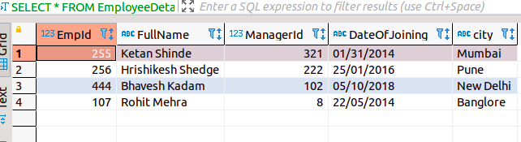

**Table 2**

CREATE TABLE EmployeeSalary

(

EmpId int,

Project nvarchar (255),

Salary int,

Variable nvarchar (255)

)

Select * FROM EmployeeSalary;

INSERT INTO EmployeeSalary (EmpId,Project,Salary,Variable)

VALUES ('107','p4','30000','200')

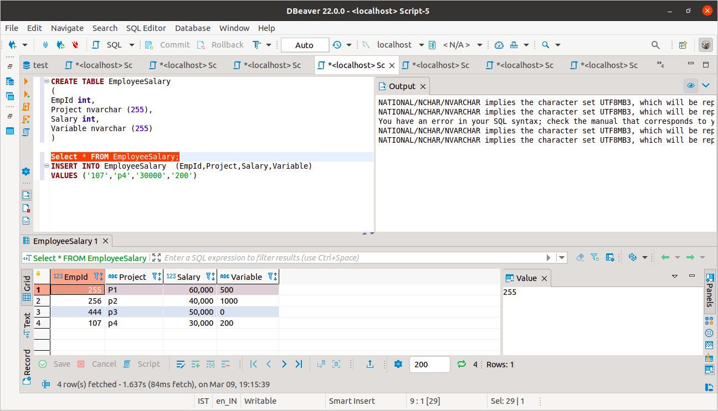

2.Get Employee Detail having Max Salary

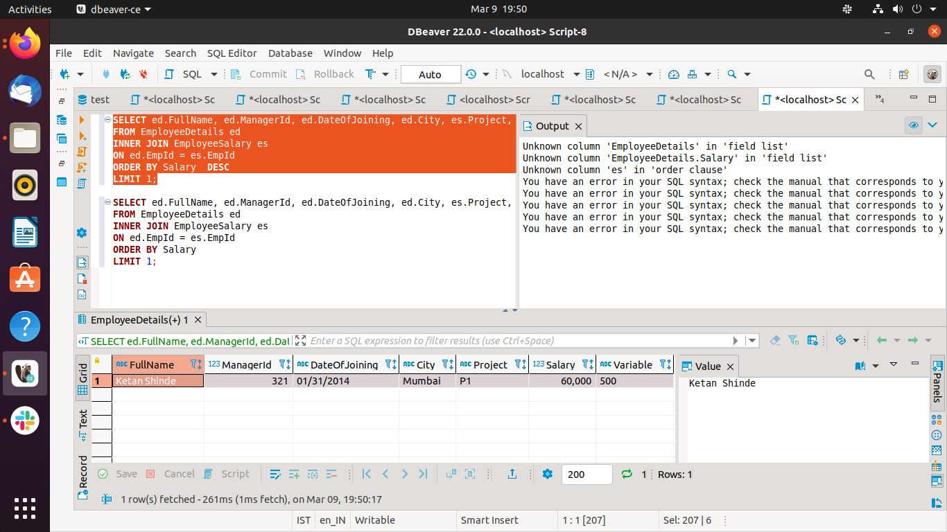

3.Get Employee Detail having Min Salary

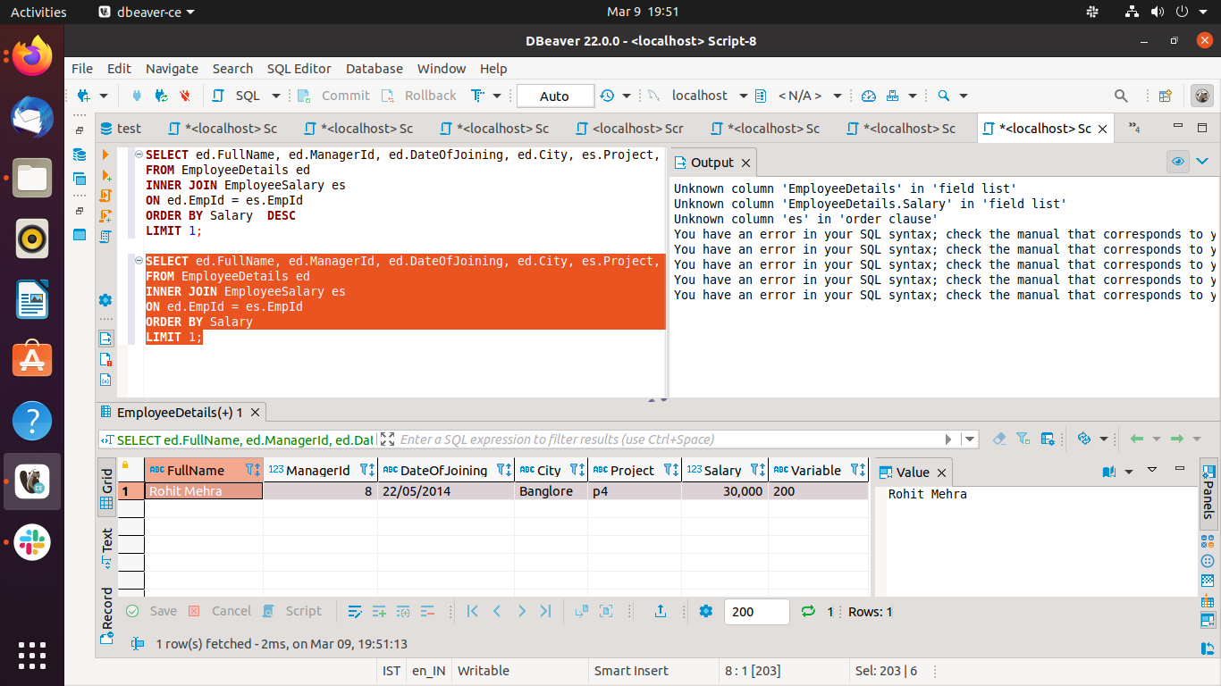

4.Get Employee Detail having Last Name Starting with “R”

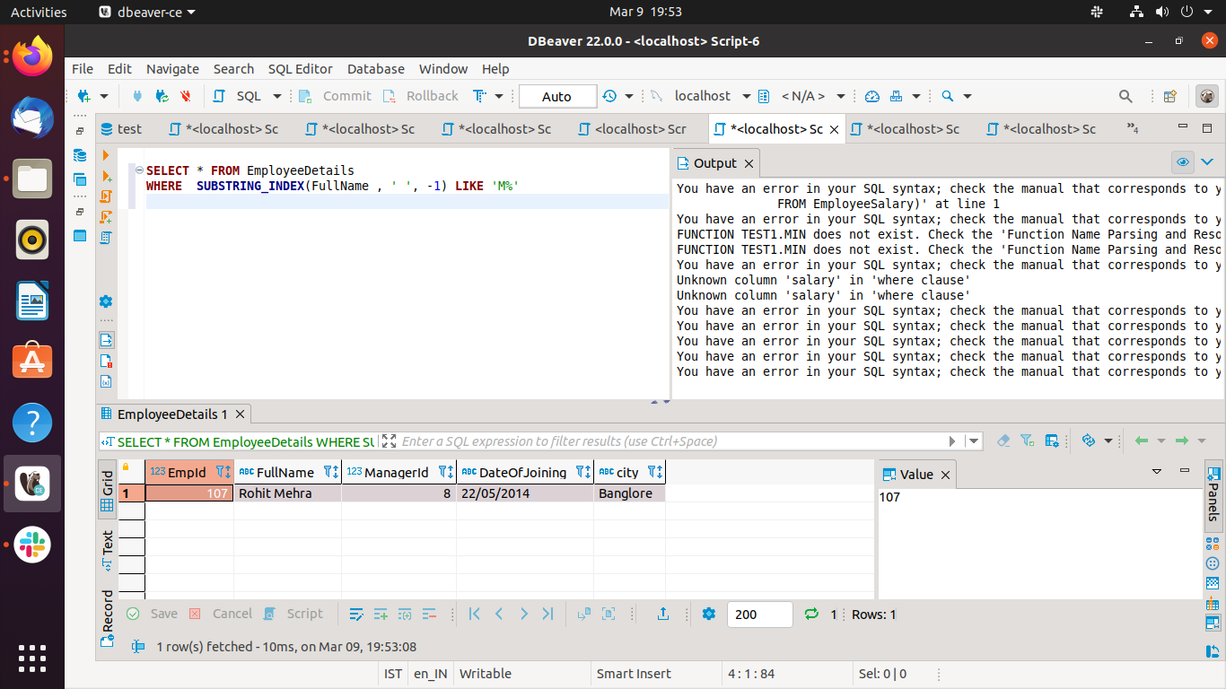

5.Get Employee Detail with columns

